TASK 2

# Hardcoded dictionary with stock prices

stock_prices = {

"AAPL": 180,

"TSLA": 250,

"GOOGL": 2800,

"MSFT": 300

}

# Function to get user input for stocks and quantities

def get_portfolio():

portfolio = {}

print("Enter your stock portfolio. Type 'done' to finish.")

while True:

stock = input("Enter stock symbol: ").upper()

if stock == 'DONE':

break

if stock not in stock_prices:

print("Stock not found in dictionary. Try again.")

continue

try:

quantity = int(input(f"Enter quantity for {stock}: "))

portfolio[stock] = portfolio.get(stock, 0) + quantity

except ValueError:

print("Please enter a valid number.")

return portfolio

# Function to calculate total investment

def calculate_investment(portfolio):

total = 0

for stock, qty in portfolio.items():

total += stock_prices[stock] * qty

return total

# Function to save results in a file (optional)

def save_results(total):

filename = "investment_total.txt"

with open(filename, "w") as file:

file.write(f"Total investment value: ${total}\n")

print(f"Results saved in {filename}")

# Main script

if __name__ == "__main__":

user_portfolio = get_portfolio()

total_investment = calculate_investment(user_portfolio)

print(f"Your total investment value is: ${total_investment}")

save_option = input("Do you want to save the results? (yes/no): ").lower()

if save_option == 'yes':

save_results(total_investment)

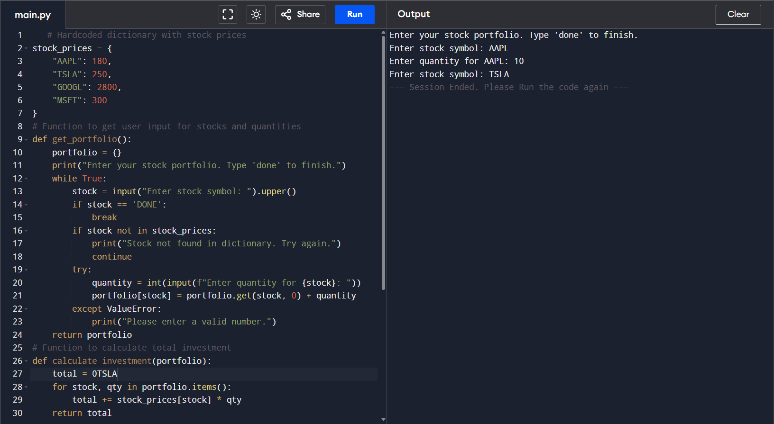

**How to Use:**

* Run the script.
* Enter stock names (e.g., AAPL, TSLA) and quantities.
* Type **done** when you finish entering.
* View total investment displayed.
* Choose whether to save the output to a **.txt** or **.csv** file.

**How it works:**

* User inputs stock symbols and quantities.
* Program checks if stocks exist in the **stock_prices** dictionary.
* Calculates value by multiplying price * quantity.
* Displays total investment value.
* Optionally saves result in a **.txt** file named **investment_total.txt**.